Kenmore west football COACHING/ALL WNY RECORDS

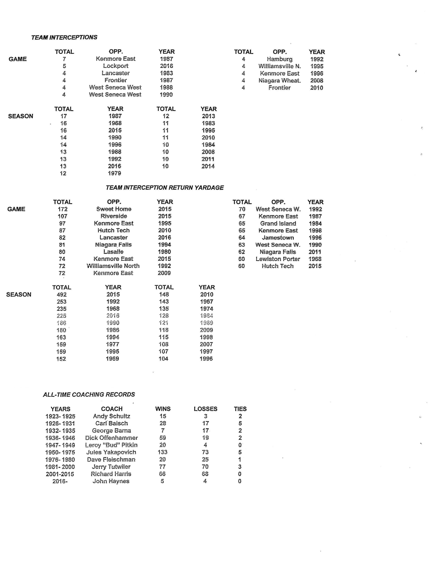

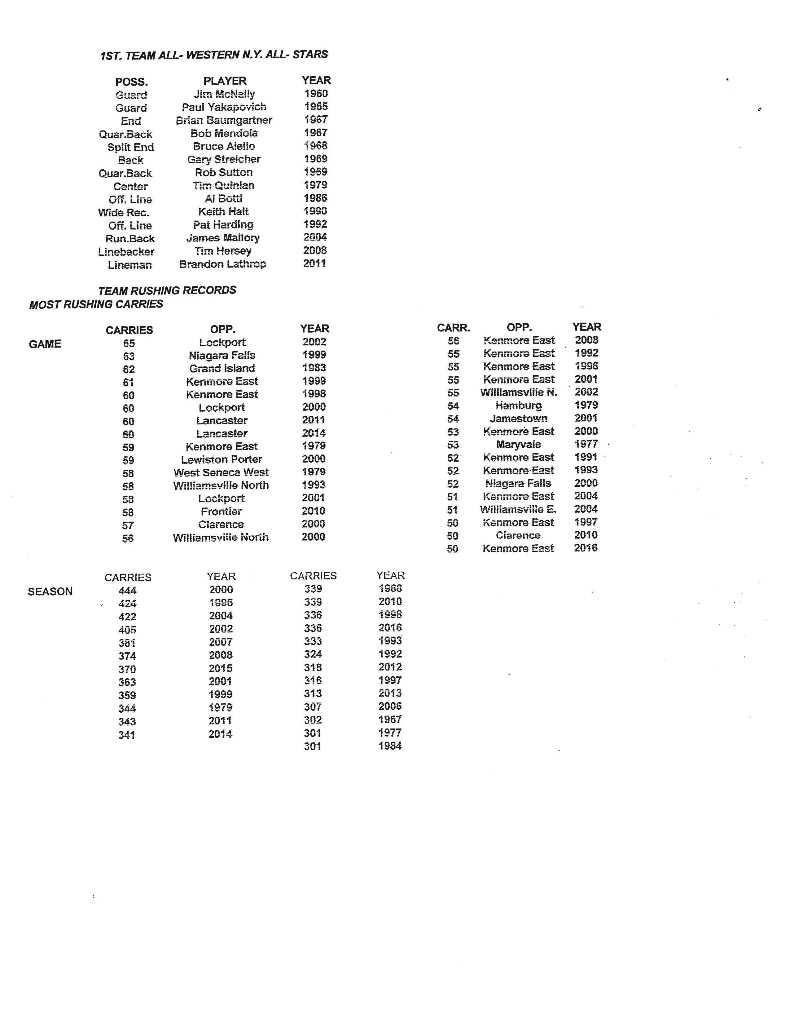

**Utility Terrell Ford 2014**

**Utility Terrell Ford 2015 Left Tackle Tyler White 2016**